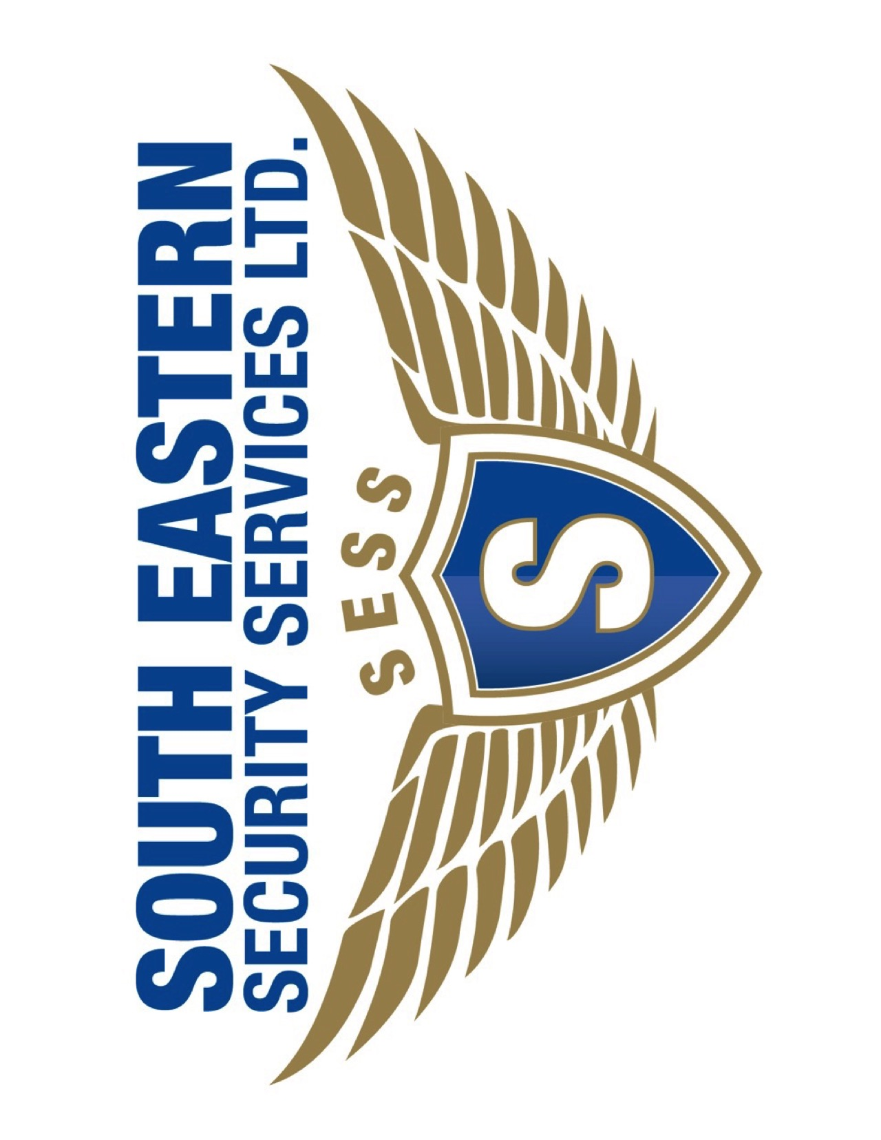

DOCUMENTS REQUIRED FOR YOUR APPLICATION

* Copy of Photo Identification: ID Card, Drivers Permit or Passport (Original must be presented)
* Copy of Birth Certificate (Original must be presented)
* Two (2) Recommendations (not older than six (6) months)
* Two (2) Passport Sized Photos
* Certificate of Character (not older than three (3) months)
* Copies of all School/Course certificates (Original must be presented)

To Be Provided **AFTER** the Interview

* Medical Certificate of Fitness – to be done **after** the interview
* Drug Test for Marijuana and Cocaine – to be done **after** the interview
* NIS & BIR Number
* Bank Account Number

Note: SESS will retain the original COC, Recommendations and Photos